page1image384

D5: Paper Prototype

Team One: Education

03/11/15

Informatics 131: Discussion A

Cassie Jeansonne 3914

Sophia Chan 6560

Sean Letzer 3320

Stevanus Iskandar 6911

TABLE OF CONTENTS

TABLE OF CONTENTS 2

PART 1: PAPER PROTOTYPE 3

Diagram 1: Interactive Learning Prototype 3

PART 2: PAPER PROTOTYPE DESCRIPTION 5

PART 3: SELF REFLECTIVE EVALUATIONS 6

Reflection one: Cognitive Walkthrough 6

Reflection two: Heuristic Evaluation 10

PART 4: THINK ALOUD SESSION 16

Session one 17

Session two 18

PART 4: REPORT 19

PART 4: PAPER PROTOTYPE REFLECTION 20

PART 1: Paper Prototype

DIAGRAM 1: Interactive Learning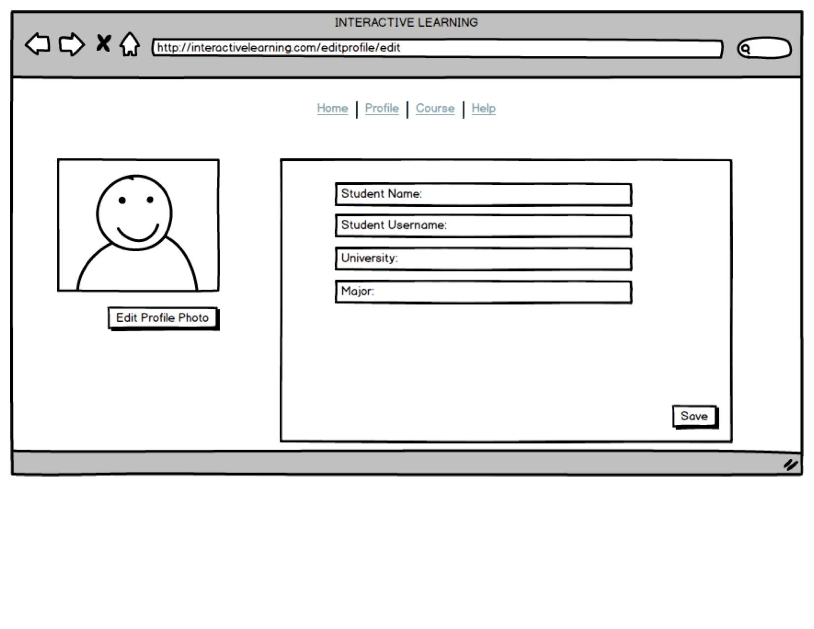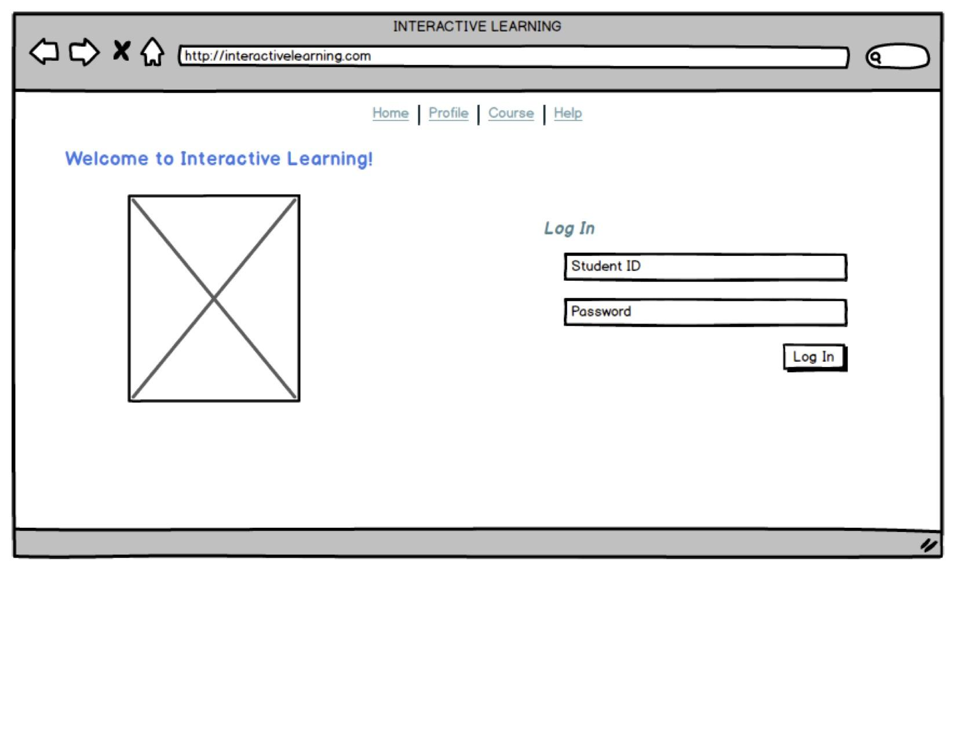

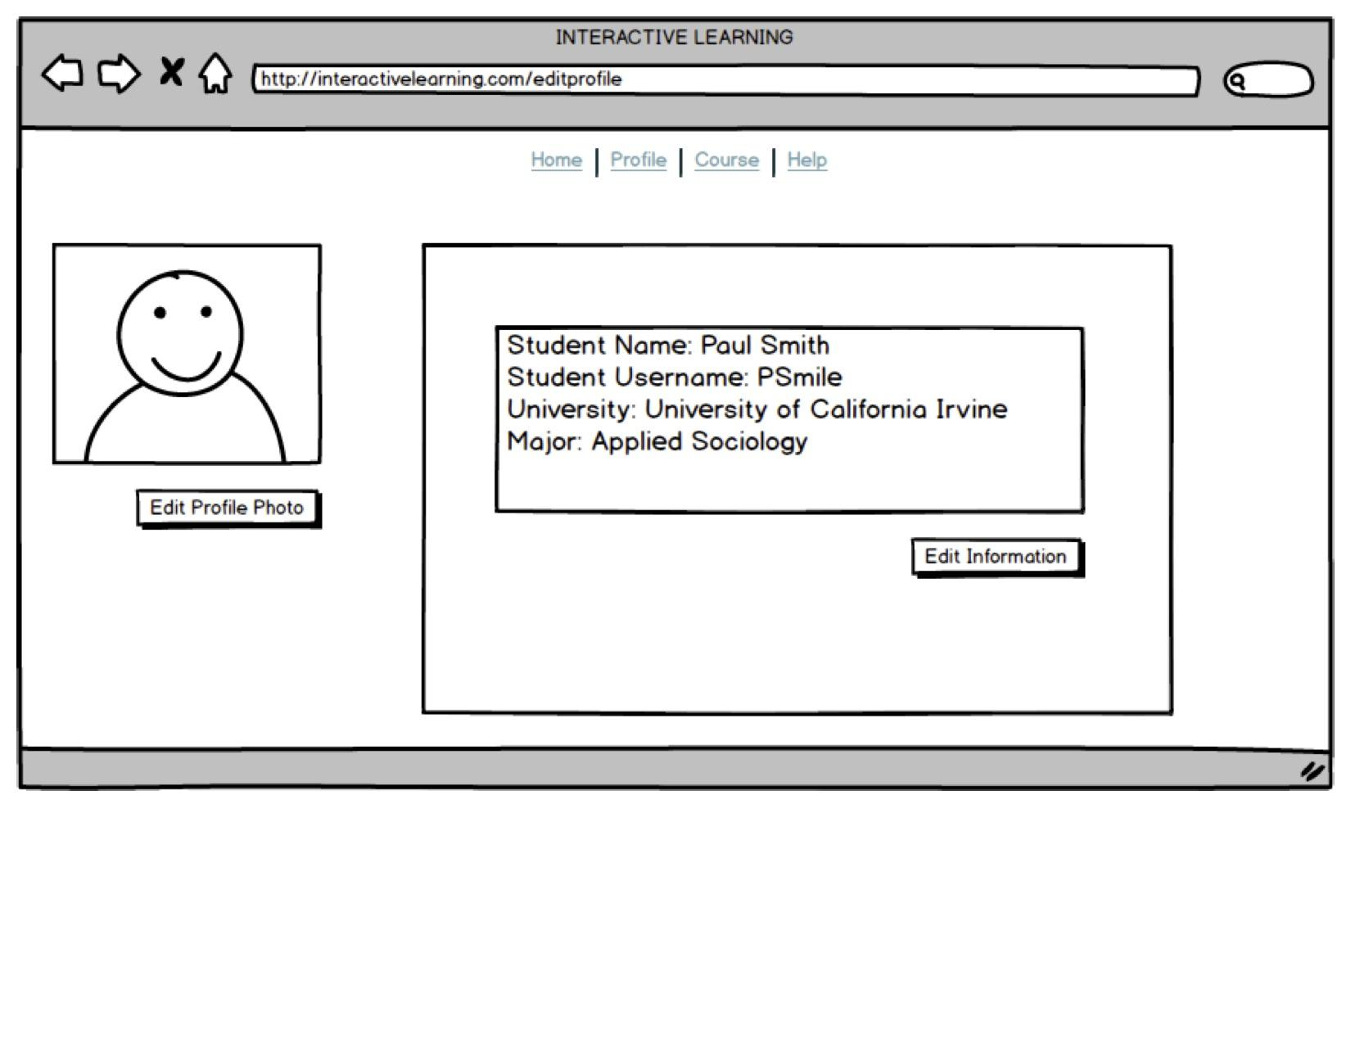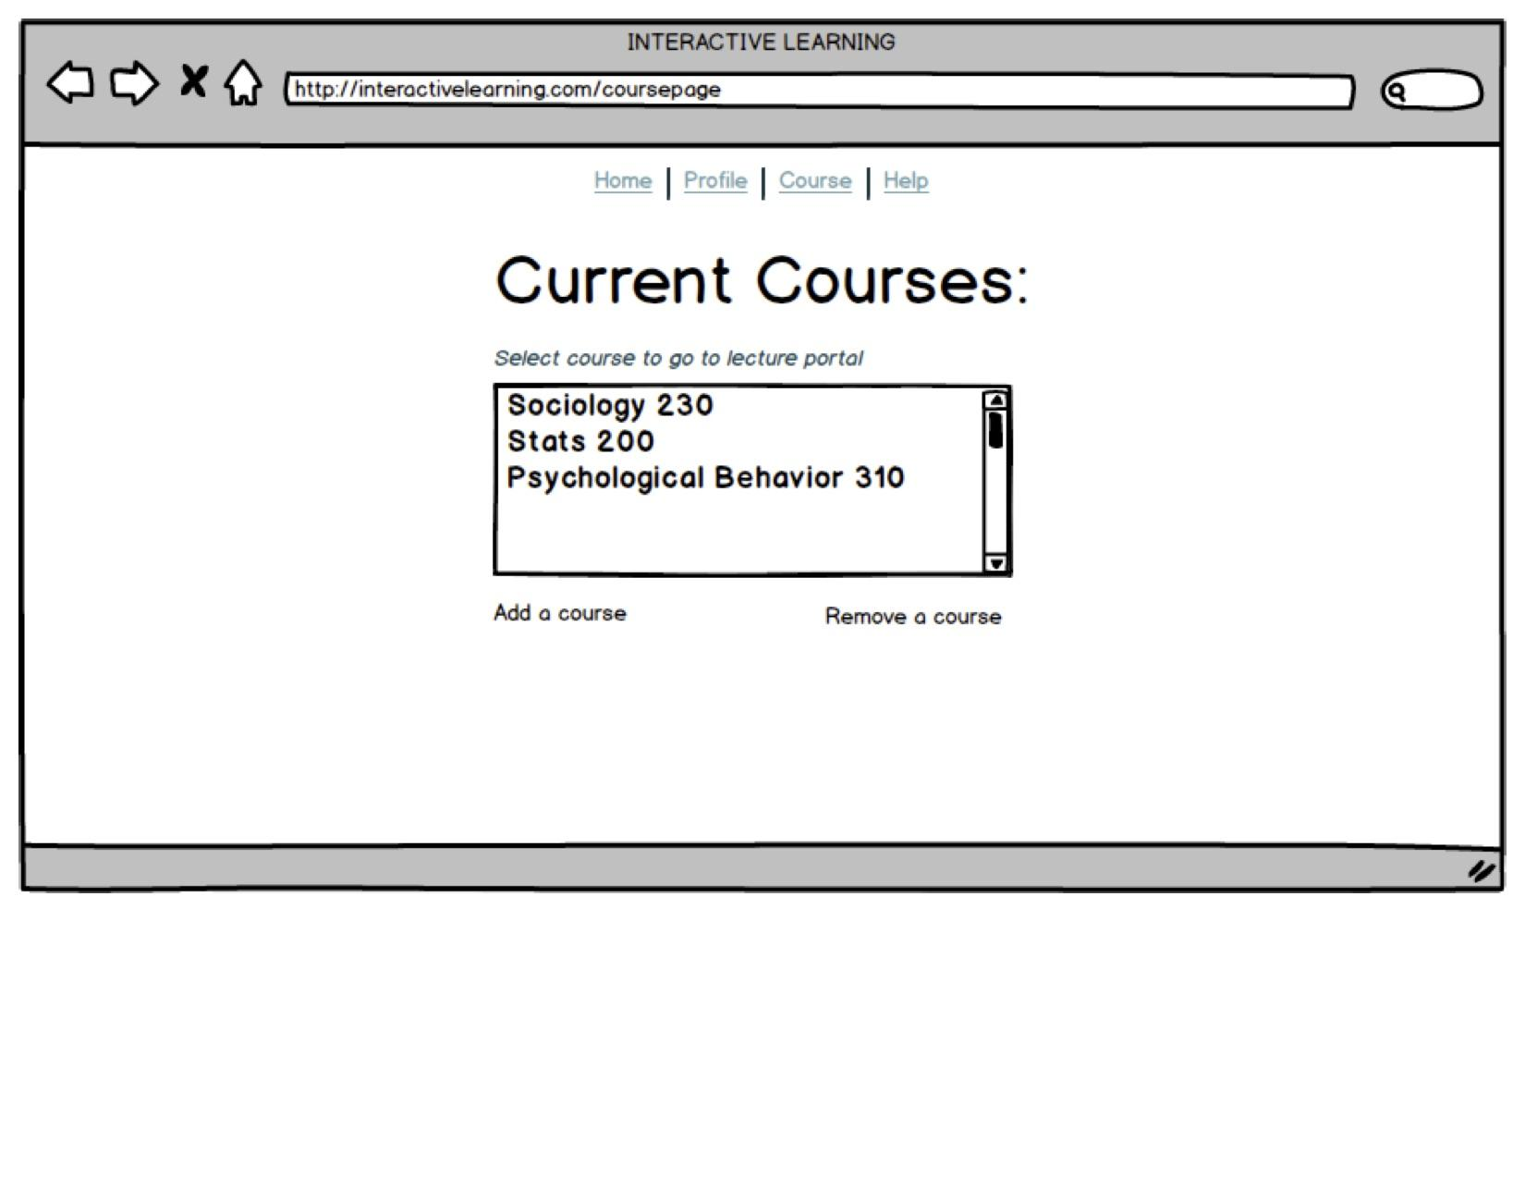

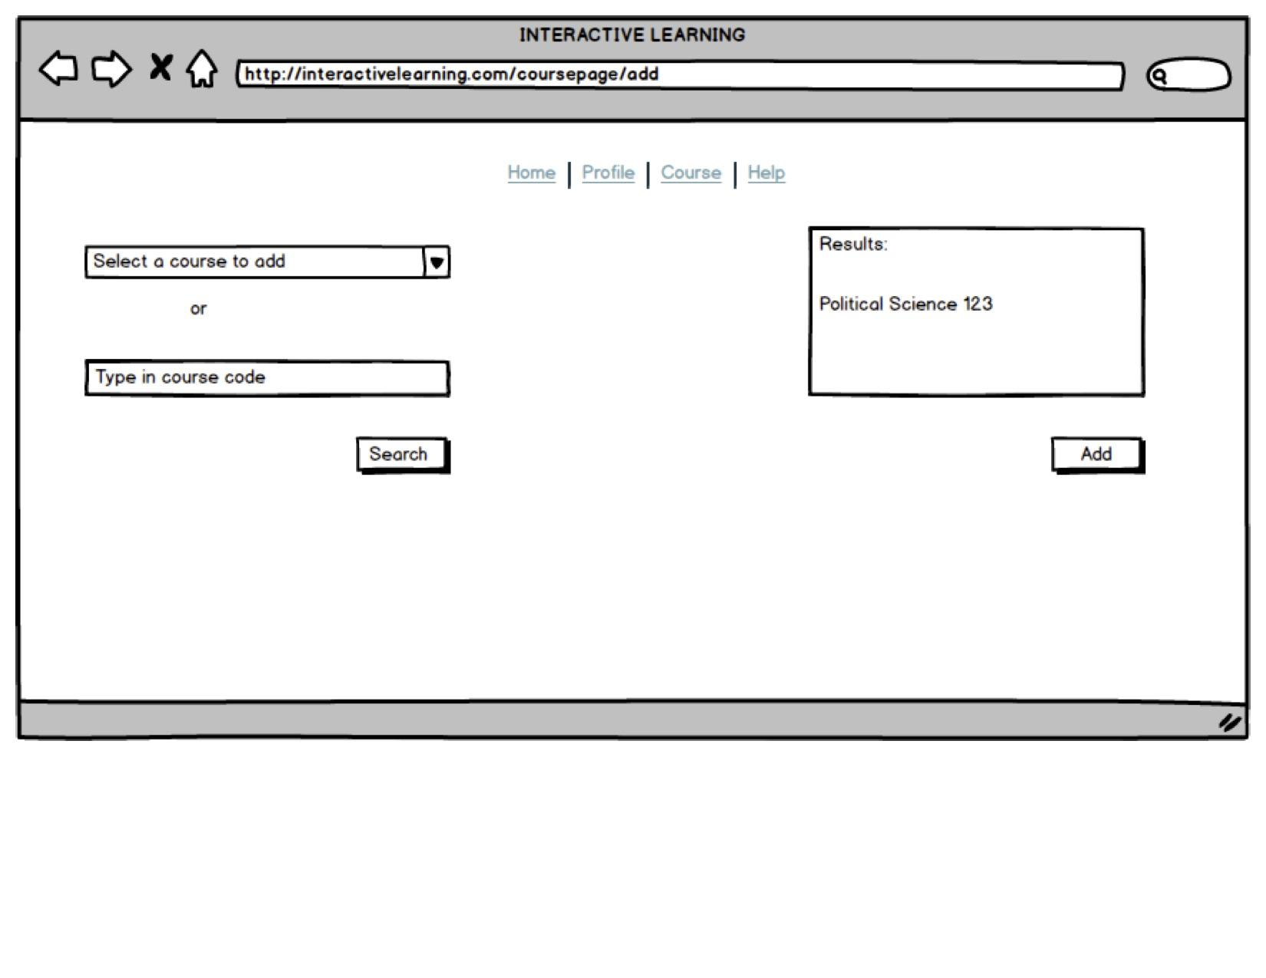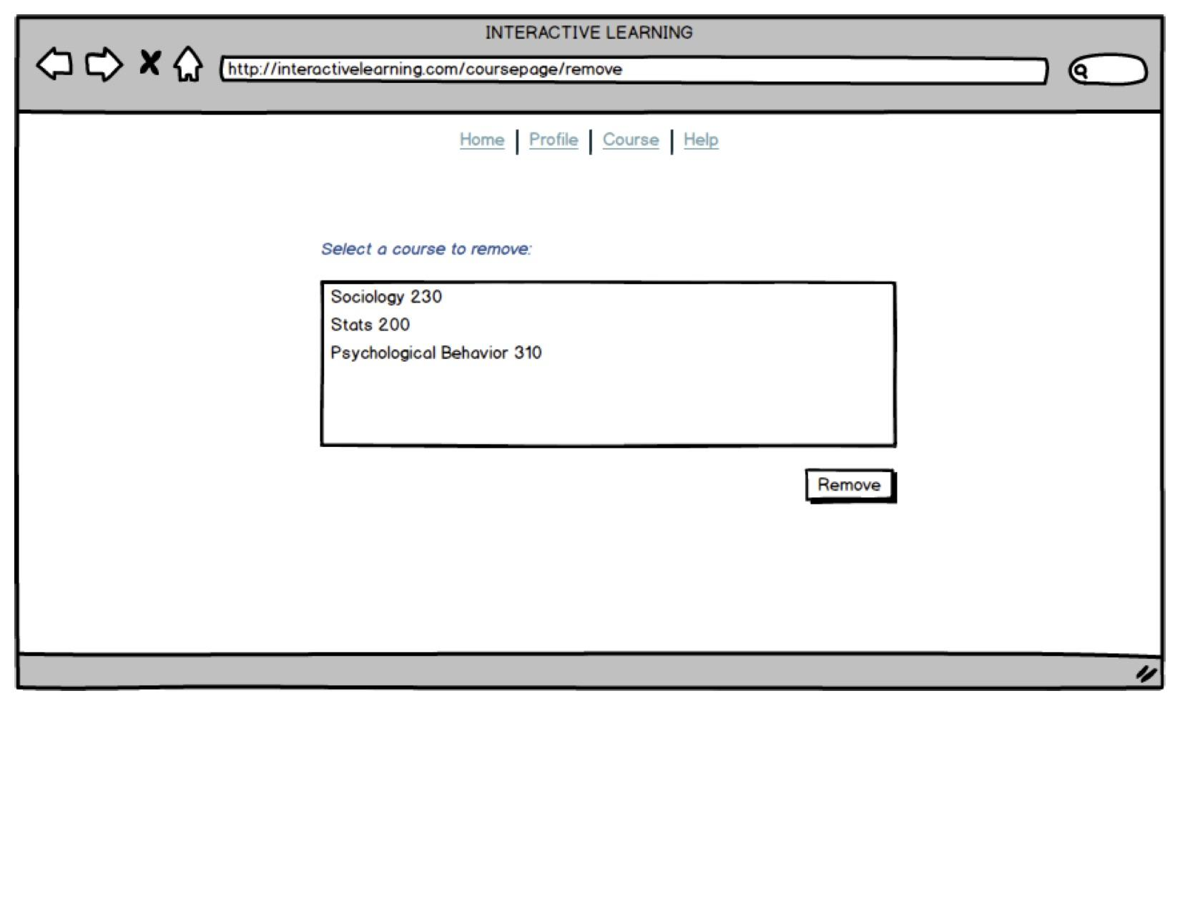

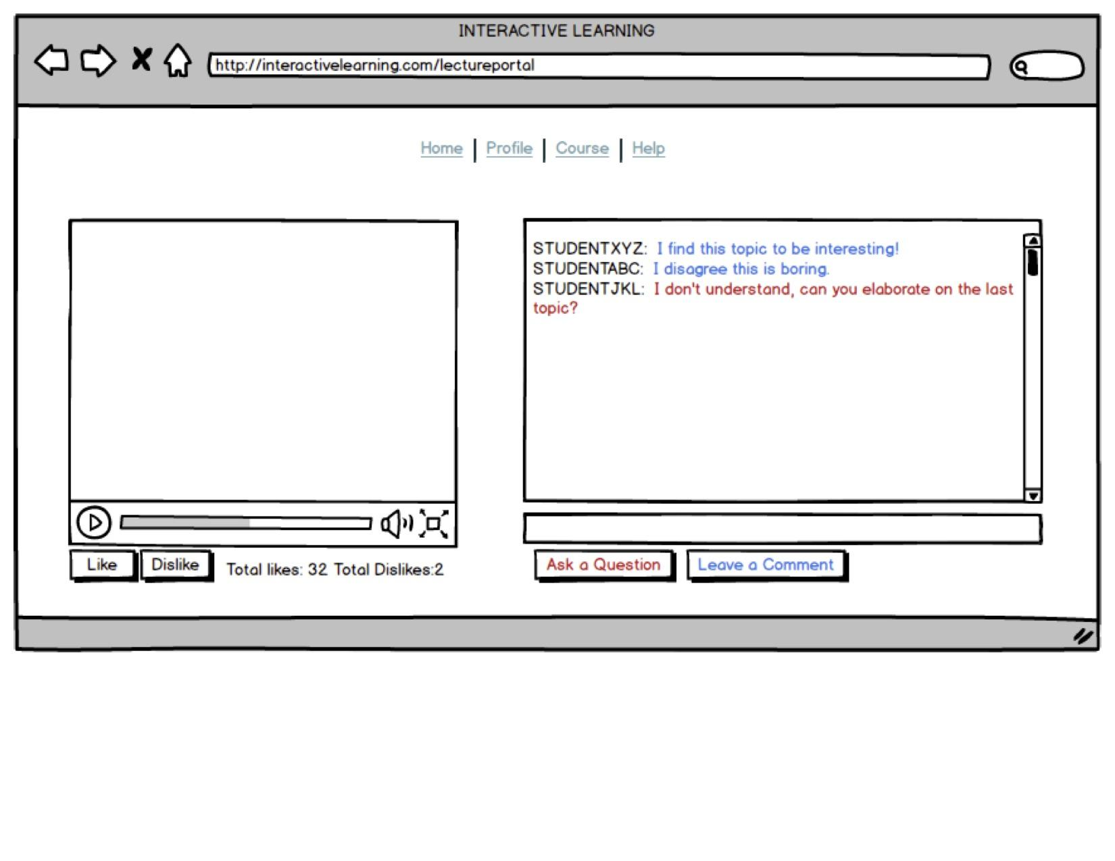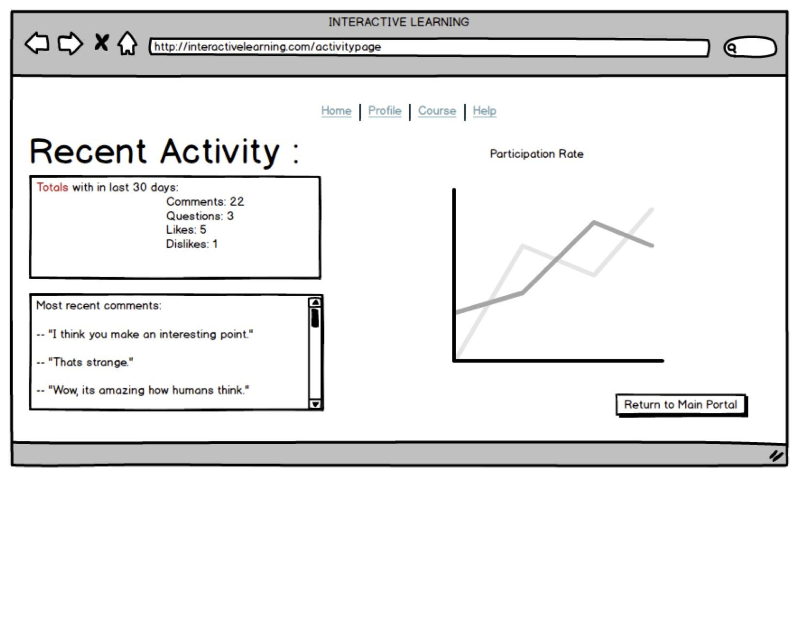

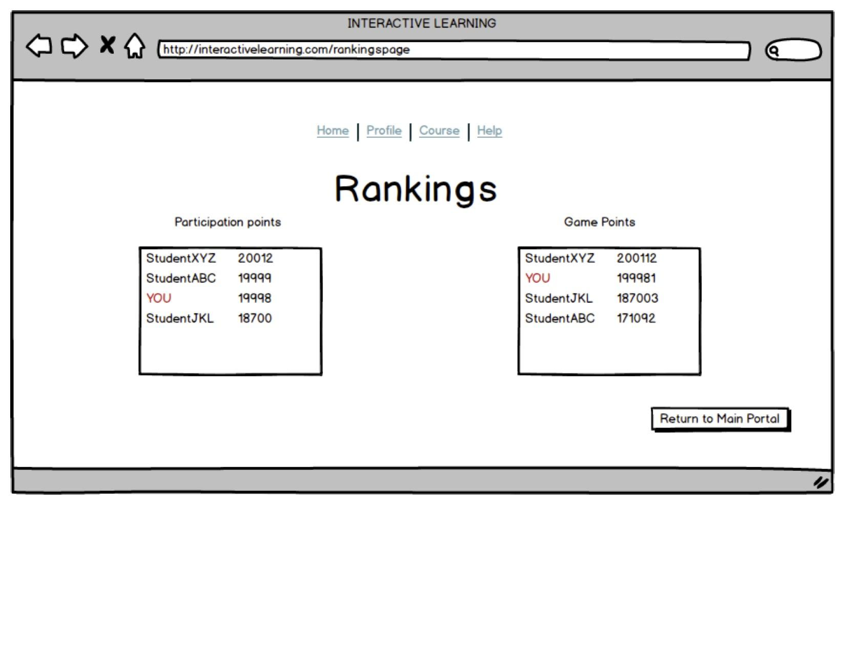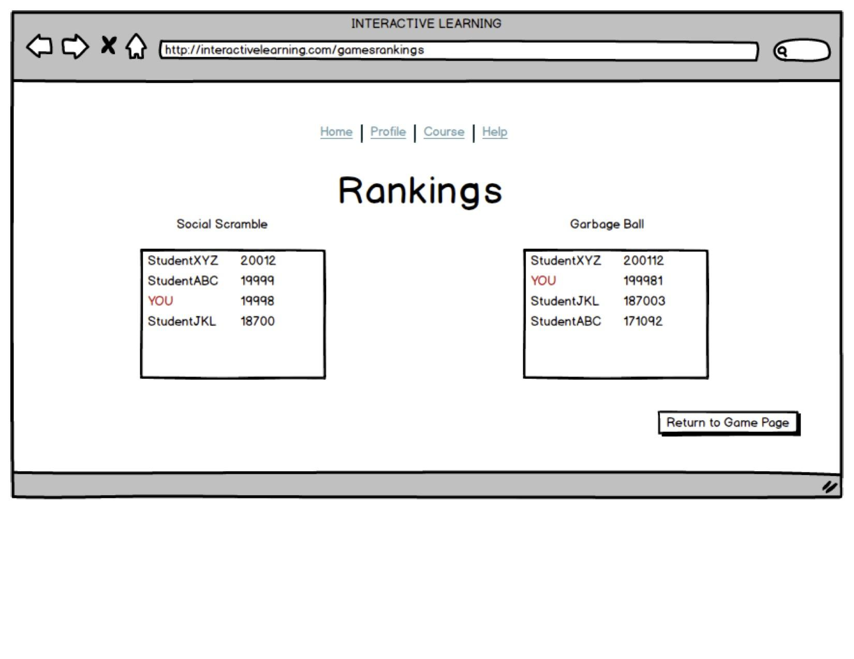

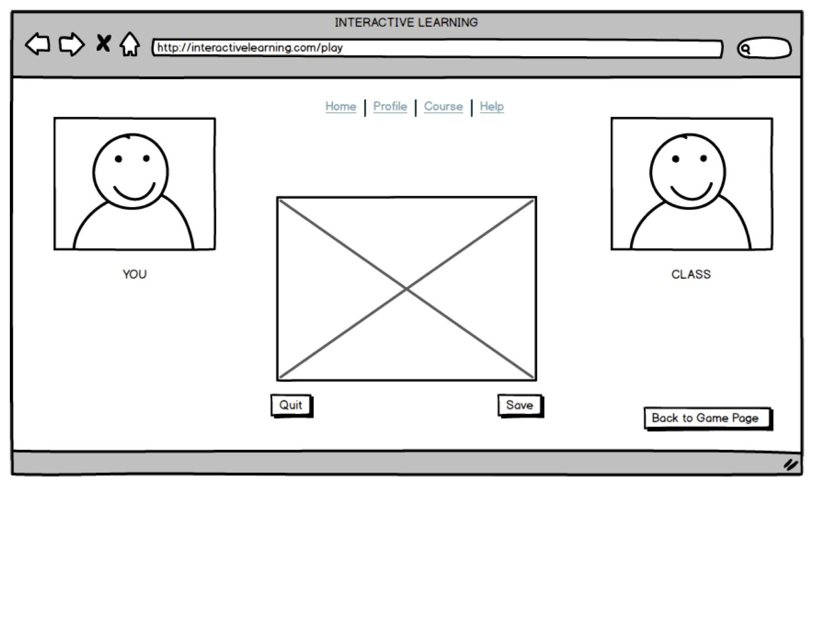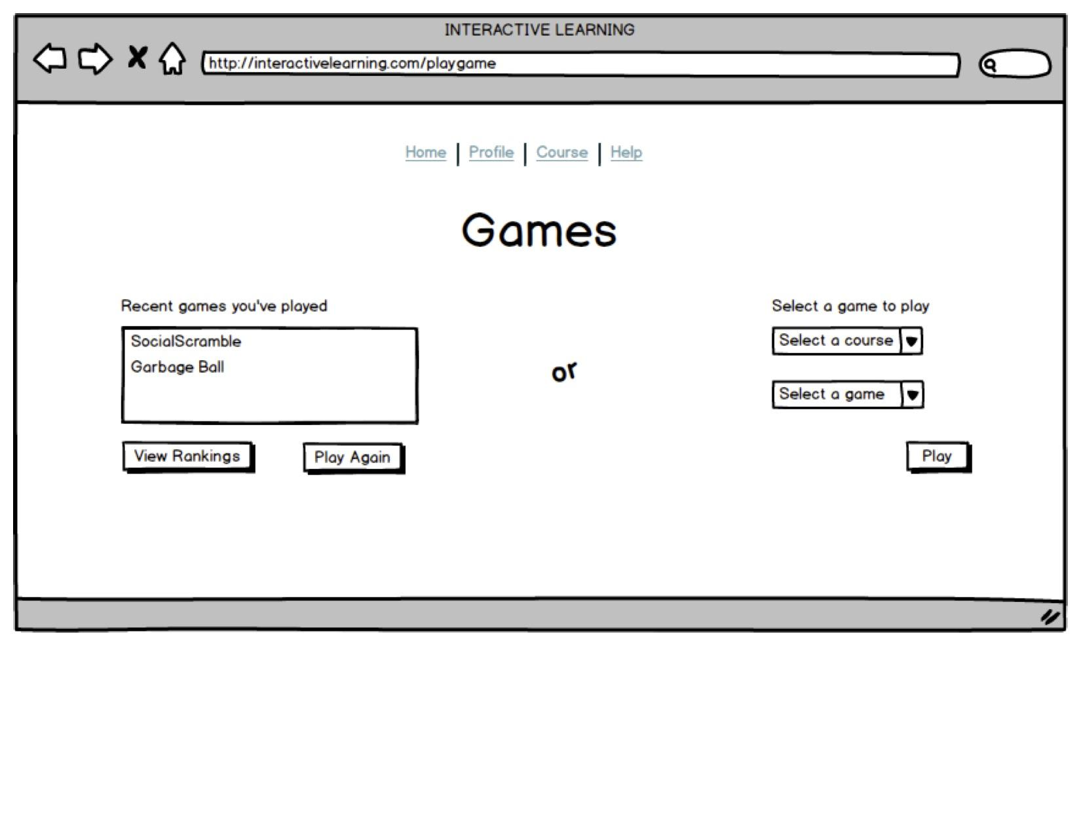

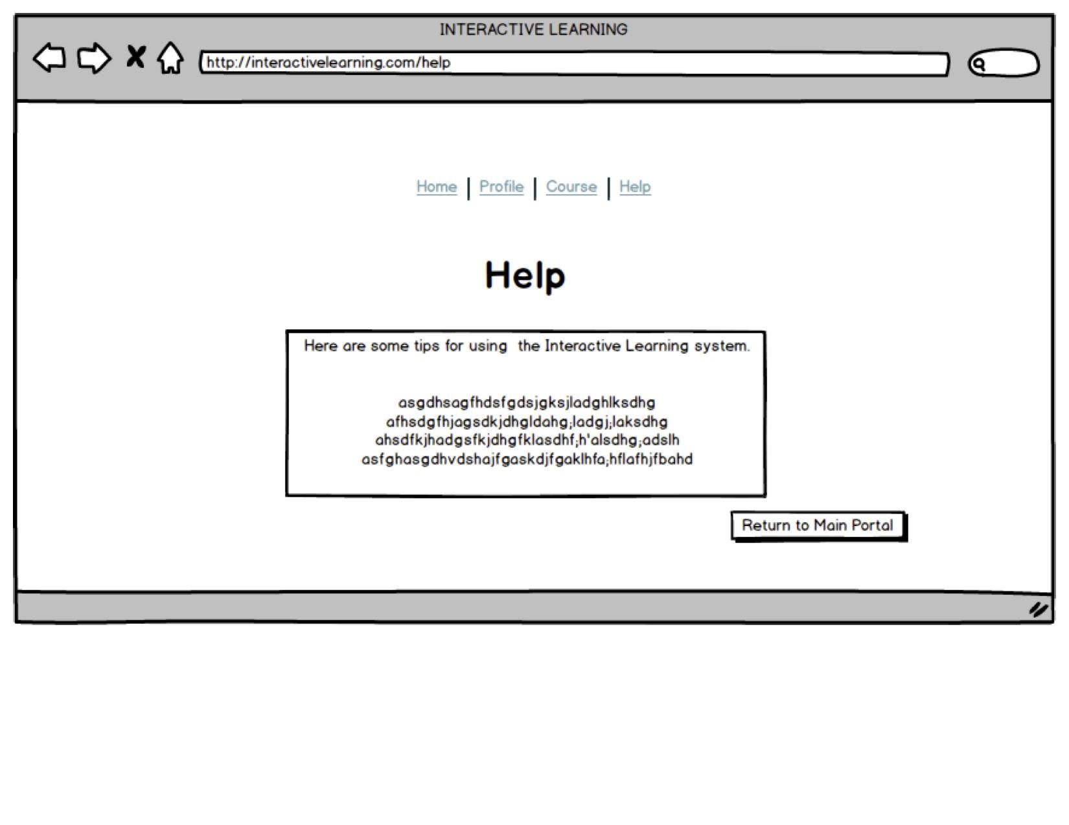

***The below link is to our prototype in our google drive folder, it will allow you to interact with our system in the way we attended.***

[Interactive Learning Prototype](https://drive.google.com/open?id=0B3zp-JBT2Ln_Mk5SdVlHZWxtTjQ&authuser=0)

PART 2: Paper Prototype Description

The method that we chose to utilize was *experience prototyping*, due to its appropriateness of our solution. Experience prototyping is meant to be some kind of representation of our solution that can allow users and testers to be able to understand, explore and see what it is like to engage with our system. Since our solution is intended to be an interactive software, using Balsamiq gave us a better feel for how the system might be like when implemented. This was achieved via use of balsamiq mockup software. Balsamiq enabled us to quickly and effectively put together an interactive mockup of various user experiences/usage. We chose Balsamiq because it was a simple tool that allowed us to create an interactive prototype of our system. Other methods such as paper prototyping, had too limited a scope to capture the essence of what our solution would be providing. The prototype we created reflects the main level of the functions of our system, such as allowing a user to login, edit their profile, access the interactive lecture portal, view rankings, and play a game. What we found difficult to represent in our prototype was the game version of the system. Ideally, our system would allow the users to play a game during lecture in augmented reality. This was not feasible to depict in our prototype using Balsamiq, so we opted to show a simplified game interface with the understanding that it would be expanded upon at a later date. Although we decided to not prototype the game aspect of our system in detail, we did focus on the user’s experience using other features such as editing their profile, adding/removing courses, accessing the interactive lecture portal, and viewing rankings.

The prototyping experience was interesting because it really made us think thoroughly about what features our product needed to have. Originally we planned to do a paper prototype, but then discovered the challenges with creating a seamless transition from one page to another. We felt having to constantly switch papers when a user selected a new task was too cumbersome to what we were trying to achieve. In the end, we decided on Balsamiq to simplify our user engagement tasks. When creating the prototype, there were several times where we needed to backtrack because there were features we needed to add in certain areas that we missed during our initial planning stage. During the process of making the prototype we also discovered features we did not need and others we would like to add. The prototyping process was important because it helped us visualize what our system would look like and what type of functions it would have as well as allowing us to interact with it. We felt that Balsamiq really allowed us to create a majority of the features we wanted to use with relative ease. In the future, we could see Balsamiq as a viable prototyping tool to use again.

PART 3: Self Reflective Evaluations

**REFLECTION ONE**: Cognitive Walkthrough

***Cognitive Walkthrough Report (CWR)***

|  |
| --- |
| CWR Number: 00123 |
| Product Name: Interactive Learning System |
| Task Name: Enter the STATS 200 interactive lecture, then check class rankings |
| Date and Time of Study: March 07, 2015 2:00-2:30 pm |
| Experimenters’ Names: Cassie Jeansonne and Sophia Chan |

**Task Description:**

*We want our users to be able to log on the system, enter the main portal, select a class from the course list and interact with the interactive lecture environment. After, we would like our users to be able to check their rankings in the class.*

## Task Action Sequence:

1. *User: Go to interactivelearning.com*
2. *System: Prompt user for unique username and password*
3. *User: Log in to the system*
4. *System: Direct user to the main portal of the system*
5. *User: Select Enter to enter the course page portal*
6. *System: Bring up page with the user’s currently enrolled courses*
7. *User: Choose a course they would like to enter a lecture on*
8. *System: Bring up the selected course’s interactive lecture*
9. *User: Interact with the system*
10. *System: Allow user to add comment, like, and ask questions * not completely functioning in prototype*
11. *User: Select Profile tab at top to go directly to main portal again*
12. *System: Bring up main portal page*
13. *User: Select view Activity Page*
14. *System: Bring up Activity Page*

**Interface/tool/system description:**

*The system is a web app that allows professors and students to interact with it in order to provide an engaged experience in the classroom. The system is located on over the internet and can be accessed from any desktop, laptop, or tablet. The system will work in any updated browser.*

## Streamlined cognitive walkthrough (Spencer et al, 2000):

|  |  |  |
| --- | --- | --- |
| CW Question | Issue? (or potential issues) | Notes |
| Will the user know what to do at this step? |  |  |
| Step 1: |  | User must enter web address correctly |
| Step 2: | User enters incorrect information |  |
| Step 3: |  |  |
| Step 4: |  |  |
| Step 5: | There are more than one option to enter the lecture portal |  |
| Step 6: |  |  |
| Step 7: | A course enrolled not listed / can’t add it |  |
| Step 8: | Professor has not opened lecture portal for that class | In the future, it would be good to prototype the professor’s interface as well |
| Step 9: | No explicit back button |  |
| Step 10: |  | System doesn’t give a clear way to remove comments, unlike something liked, or resolve a question |
| Step 11: | Not clear how to go back to main portal |  |
| Step 12: |  |  |
| Step 13: | No explicit back button |  |
| Step 14: | No explicit back button |  |
| CW Question | Issue? (or potential issues) | Notes |
| If the user does the right thing, will they know that they did the right thing and that they are making progress towards their goal? |  |  |
| Step 1: |  | The site should load. If it is down for maintenance, there should be a message telling the user that it is down for maintenance and the estimated time it will be back up. |
| Step 2: |  | Should prompt user for username and password. |
| Step 3: | If the user is a new user, there is no way for them to enter in the correct information. Or perhaps, the system logs them in as the wrong user. | User should never be a new user, the system should connect with the school’s ID given to them. However, system should never log a user in as a wrong user since each user has a unique ID and password. |
| Step 4: |  | System should bring up main portal. |
| Step 5: |  | System should give some verification that the user selected “Enter” such as a loading icon or something. |
| Step 6: |  | System should bring up courses. |
| Step 7: | Maybe not all the courses the user is taking are listed or a wrong course is listed. | There should be a help function offered by the system, or someway to contact the system administrator. Or an option for a user to manually add a course. |
| Step 8: | The professor’s lecture slides may not show up or the incorrect slides may show up. | There should be a function where the user (a student) can notify the professor that the incorrect slides are up. |
| Step 9: | Student may find it confusing on navigate around the system. | System should have a help function, or a website “map.” |
| Step 10: | Student may not notice the buttons to “LIKE, COMMENT or QUESTION.” | System should make the “LIKE, COMMENT, or QUESTION” buttons visible to user (making them large or highly contrasting from the background). |
| Step 11: | User may not know to click on the Profile tab to go to the main portal. | System should have a help function that explicitly states how to get to different pages or just answers questions users may have. |
| Step 12: | The System may bring the user to the wrong page. | There should be explicit back buttons offered on each page. |
| Step 13: |  | System should show a loading icon. |
| Step 14: | System may bring up the wrong page. | There should be explicit back buttons offered. |

**Potential fixes for discovered problems:**

*With the Interactive Learning system, the biggest problem is the user may not know how to navigate the system correctly due to lack of back button. This might be fixed in one of two ways:*

1. *Add a back button on each page and clearly mark the other buttons functions.*
2. *Have a scroll over window that notifies user which page the will be going to.*

*The first solution, adding a back button it most likely the best solution. It eliminates a number of secondary problems, including user incompetency, unclear decision making, and system feedback errors .*

*Another problem users may encounter is if the System does not bring up the correct page or the incorrect lecture slides/notes. This can be fixed using the following options:*

1. *Provide a way for the user to notify the professor if the incorrect lecture notes/slides are presented to them. There should also be a separate notification button they can use to notify the system administrator of the issue.*
2. *Add an explicit back button and home page button to allow a user to navigate themselves to the correct page. Also add a button so the user can notify the system administrator of any problems with the System.*

*Both solutions could be implemented. However, the best solution is a way to implement both solutions because having an explicit back button would be very useful for more experienced users who know how to navigate the system. Having an explicit home button would do the same for users, allowing them to essentially “restart” from the beginning and allow them to navigate around the site by themselves. Potential drawbacks for both solutions is that the system administrator may be overloaded with notifications that all mention the same problem. In such a case, there should be a way for the System to organize the different notifications based on their problem and time stamp how many people notified the system of the problem as well as how often the problem was encountered.*

**REFLECTION TWO**: Heuristic Evaluation

|  |  |
| --- | --- |
| No. 01 Heuristic Evaluation | Visibility of system status |
| **Name:**  Good indication of where the user is in the mapping of the system | |
| **Evidence:**  Visibility of system status is preserved throughout the navigation between page to page. Once logged in (which is clearly displayed to the user by brightly colored titles of each page, letting the user know which screen he/she is currently on), it is easy to identify what part of the mapping you are on. The main navigation bar that headlines the top of any given page will change color to indicate where the user is when navigating. | |
| **Explanation:**  This design meets the heuristic of system visibility because users of most systems are accustomed to having a central navigation bar on either the top of the page or on the side. Here we honor what the user is accustomed to, so habitually users are likely to look at the top to see where they are or how to navigate outside the flow of the site map. With color change on the link of the users current site, users are aware of their current state within the system. At the bottom of each site, we have a back button that will allow for the users to be able to tell the prior state of the system. | |
| **Severity or Benefit:**  ***Rating: 0 not a problem of usability***  **Justification (Frequency, Impact, Persistence, Weights):**    **Frequency:**  The average user will not make mistakes based on system status. Most of the status has to do with navigation, and the system status needed upon navigation of sites, is merely to know what page one is on, and how to navigate to a past state given an error or misclick. The game portion will have a built in status and a much more interactive one, like a dynamic score counter, flashing lights upon scoring a goal or point, charts and graphs post game, etc.  **Impact:**  Users that misclick or have in error in navigation or interacting with a piece of the system is low in terms of time wasted. This is because on almost all interfaces we also have measures that inform and enable users to go back to the prior state of the system. Like giant go back buttons. Users usually notice they navigated wrong at the top of the page or end, so it is recovery time is optimal.  **Persistence:**  Number of errors is dependent on the user, but our system/site does show exactly where the user is so users will eventually learn the mapping of the system. | |
| **Possible solution and/or Trade-offs:**  With respect to persistence of navigation errors, a possible improvement could be to implement code that will generate a preview image when a user scrolls over a link in the home navigation header. This way our system will have full scope of states that a user is in, had been, or could be. A user will have a button enabling the user to go back to prior state, the user is indicated which site he/she is on by the color code of the links, and the user could also see a preview of future state before committing to clicking on a link.  Trade-off:  Implementing code that will handle this type of preview, could cause some confusion to really novice users, and could be an inconvenience for the advanced user. Not to mention it could compromise the performance of the site, and slow navigation would reduce the overall usability of the system/site. | |
| **Relationships:** | |

|  |  |
| --- | --- |
| No. 02 Heuristic Evaluation | Aesthetic and minimalist design |
| **Name:** No irrelevant information and information is provided accordingly to the user’s needs. | |
| **Evidence:** One example is the ‘Edit Profile’ button in the main portal. As expected by the user, it brings you to an interface where you could edit your profile by changing your photo or information. These are the only things that you can do in the ‘Edit Profile’ window.  The ‘Rankings’ windows show participation points and the game points acquired by each user and arranging them in descending order. These are the only information provided in the ‘Rankings’ window. | |
| **Explanation:**  There are no irrelevant information on any of the windows/tab. All information and features are provided accordingly to their respective feature title. The information provided are also concise and easily understood by the users.  In each window, the user interface is simple and easy to navigate. There are no unexpected behaviors for any of the features. | |
| **Severity or Benefit:**  ***Rating: 0 (not a problem of usability)***  **Justification (Frequency, Impact, Persistence, Weights):**    Frequency: The minimalist design is commonly praised by the users and noticed after they test out the application.  Impact: The impact of this design makes the application really easy to use and navigate. The users were able to achieve their intentions rather quickly.  Persistence: The minimalist design is consistent in all the features, and doesn’t interrupt the user’s tasks.    Weights: This is a positive aspect of the design, and does not in anyway interfere with the usability of the application. This is why it has a rating of 0. | |
| **Possible solution and/or Trade-offs:**    Extra information that the user might be interested in is not provided because of the minimalist design. Information that might be somewhat relevant or indirectly correlated is not presented in this application. | |
| **Relationships:** | |

|  |  |
| --- | --- |
| No. 03 Heuristic Evaluation | Error Prevention |
| **Name:**  “Oops I didn’t mean to delete that, f@#$” | |
| **Evidence:**  Users of novice experience will be likely to accidentally remove classes when on the course page site. Here there is two buttons at the bottom of the display box: add a course, and conversely remove a course. Both of which have the same size, color, and texture, and they happen to be equidistant from one another. | |
| **Explanation:**  Novice users can very easily remove a class from their schedule because the two options look similar and perform similar functions. However, this is dangerous, and frustrating to the end user, because the time it would take to recover from an error like that would be tremendous. For the expert user, the orientation may be confusing as well and because the size and shapes are identical, so if navigating quickly it is easy to trip up, even for an expert. | |
| **Severity or Benefit:**  ***Rating: 4 catastrophe***  **Justification (Frequency, Impact, Persistence, Weights):**    Frequency: Users would commit this type of error frequently, especially when adding/removing a lot of classes back and forth. It is too easy for the mind to confuse the two, since there is not enough differences present graphically.  Impact: Once a user has accidentally removed a class, they will have to look it up again, add it, and then continue doing whatever operations they were prior. This will take a colossal amount of energy, time, and patience to recover from. For novice users, it could turn them away from using the system entirely, especially if they cannot see the value right away.  Persistence: It will be a one time error for novices, probably because the frustration will make them remember their actions. For experts rushing through the processes, it will be an ongoing error/mistake, just because of muscle memory. Normally the brain will enact muscle memory the second it recognizes rough spatial location and geometries, probably faster than you can read the buttons, so it will most definitely be an error.  Weight: Given the novice profile, I rated this heuristic as a 4 because although the frequency and persistence is low for novices, the impact will be great enough to possibly lose a customer/student. For expert users, it will be a slight more frequent, but persistent error that will cause a lot of frustration, but if they made it to expert status, probably the impact wasn’t great enough for that particular user to stop utilizing the system. Analyzing just the slightly dire situation an expert user could come in contact with, it seems like the situation would be ranked as a 3 (major usability problem), but given the worst case scenario of losing a client, I rank this as a 4 (catastrophe). | |
| **Possible solution and/or Trade-offs:**  A possible solution, would be to make the add class button 2 or 3 times bigger than the remove, and make it a bright positive color (by American culture) like green, as to promote primary action choices. Diminishing the remove button in size, and add a dangerous/prohibitive color like red to suggest this is a secondary action.  Trade-offs could include: the system UI is less aesthetically pleasing, or users may have a better chance of information overload/task pile up (ultimately slowing down their performance). However, the reward of preventing errors, trumps the possible downfalls of this UI change. | |
| **Relationships:** | |

|  |  |
| --- | --- |
| No. 04 Heuristic Evaluation | Consistency and standards |
| **Name:** Navigation Bar and Buttons. | |
| **Evidence:** In the main portal, there are four underlined centered text on the top of the page and five rectangle shaped buttons on the bottom page. Underlined text that are centered on top of a page usually acts as navigators of the application. It usually appears in every page and retains its position. The application was able to fulfill this consistency and standard. For the rectangle shaped buttons, the standard is that they act as links to another page and a brief information of what the buttons links to is contained inside the button. They do not have to appear in every page. The application appears to fulfill this consistency and standard as well. | |
| **Explanation:**  Users usually take for granted the consistency and standards of any application or software. They expect ‘back buttons’ to take them back to the previous page, underlined text that changes color when hovered by the cursor to be links. If these consistencies or standards were to be changed by the designer, the result could be catastrophic. Users will be confused and lose trust on the application or software. | |
| **Severity or Benefit:**  ***Rating: 0 (not a problem of usability)***  **Justification (Frequency, Impact, Persistence, Weights):**    Frequency: The consistency and standards are usually not commented by the users because they take it for granted.  Impact: The impact of this consistency and standard lets the application be trusted by the user. The users would know what each features does without actually proving it or testing it out.  Persistence: The buttons and navigations links are consistent to the usual standards.    Weights: This is a positive aspect of the design, and maintains the expected usability. This is why it has a rating of 0. | |
| **Possible solution and/or Trade-offs:**    This limits the design of the application. Designers could not make any major changes in the consistency and standards of common features such as navigation bars and buttons. If they do change the standards, they would need to explain it in detail on what was changed and what each features actually do right now. The explanation will avoid confusion for the users. | |
| **Relationships:**  No. 02 Heuristic Evaluation.  Consistency and standards of the navigation bars and buttons correlates with the minimalist design. | |

**Summary for 10 Usability Heuristics**

* **Visibility of system status**
* **Match between system and the real world**
* **User control and freedom**
* **Consistency and standards**
* **Error prevention**
* **Recognition rather than recall**
* **Flexibility and efficiency of use**
* **Aesthetic and minimalist design**
* **Help users recognize, diagnose, and recover from errors**
* **Help and documentation**

PART 4: Think Aloud Session

Usability Aspect Report (UAR)

|  |
| --- |
| **UAR Number:**  First User Number :1234 Second User Number: 5678 |
| **Product Name:**  Interactive Learning |
| **Date and Time of Study:**  First User: Saturday March 07, 2015 Second User: Sunday March 08, 2015 |
| **Experimenters’ Names:**  Cassie Jeansonne and Sophia Chan |
| **Subject ID:**  First User: STON1 Second User: JKO2 |
| **Subject Details:**  **User One:**  Frequent user of computers and different software systems. Knowledgeable about user interaction heuristics  Age: 32  Occupation: Data Analyst at a Healthcare Company  **User Two:**  Student at a University. Would be a potential user of the system if implemented. Knowledgeable about computer systems.  Age: 21  Occupation: Student |
| **Heuristic List:**  N/A |

SESSION ONE

|  |  |
| --- | --- |
| No. UE 1234 | Problem: Unclear Navigation |
| **Name:**  Unclear Navigation | |
| **Evidence:**  The flow between pages lacks clear navigation buttons. The links at top of site do not clearly state where the go, ex. home isn’t really the home page but instead the login page. The main page is the profile page. Suggest a renaming of links. | |
| **Explanation:**  The way the system is currently designed it would be difficult for users to navigate easily around the system. A more experienced user may be able to navigate with less difficulty, but an user unfamiliar with the system would experience difficulties when using the system. | |
| **Severity or Benefit:**  ***Rating:*** 3  ***Justification (Frequency, Impact, Persistence, Weights):*** Many users would be affected by this issue, the frequency would be diminished as users familiarized with the system , although it maintains a persistent inconvenience for the user. The problem was rated at a 3 because it is highly important to the project team that the user have an easy intuitive system to use. | |
| **Possible solution and/or Trade-offs:**  Go back into system and change the buttons on each page making them more clear. Change link for home button at top to return to the main portal page, not the login page. By making the links clearer the user will have a better experience when using the system. There are no major trade-offs when making the navigation changes. | |
| **Relationships:**  N/A | |

SESSION TWO

|  |  |
| --- | --- |
| No. UE 5678 | Good Aspect: Minimalistic Design |
| **Name**:  Minimalistic Design | |
| **Evidence**:  The bare minimum amount of buttons are present. There are no extraneous images or buttons. User found it relatively easy to other than the somewhat confusing names for links. Commented on the ease of use and uncluttered feel of the system. | |
| **Explanation**:  The user found the simplistic design easy on their eyes. The site, in general, was relatively uncluttered and the background was not distracting. It was easy for them to imagine themselves using the system during class because while the options to “LIKE, COMMENT, or QUESTION” the lecture slides/notes are present, it helps them stay engaged because they imagined that they would probe deeper on the topic based on questions their peers may post or what others found interesting. Despite the technological ability of the user, the minimalistic design is easy to understand and not distracting to use. | |
| **Severity or Benefit**:  ***Rating****: N/A*  **Justification (Frequency, Impact, Persistence, Weights)**:  Since the minimalistic design was a good benefit, the rating system does not apply. The frequency of the benefit is common for all types of users, they are all likely to experience the benefits of a minimalistic design. It is easy for users to user the system because of the uncluttered feel of the system. Since it is rather not cluttered, there are less possible sources of distractions for users. | |
| **Possible solution and/or Trade-offs**:  A trade-off however of having a minimalistic design is that it may be so simple that some users may find it boring to use the system because there is not enough activity or environment that holds their interest. While the simplistic design was intended to lessen the amount of distractions, users who are more used to high-activity sites may find the site lacking in keeping their interest. | |
| **Relationships**:  N/A | |

PART 5: Report

While working on Design 5, we discovered the challenges of creating a prototype that was interactive and easy for a user to engage with. During the creation of the prototype, we realized that many of our ideas for our decided-upon solution were difficult to implement in a paper prototype form. We were not able to fully prototype the augmented reality gaming aspect of our system, so instead we decided to focus on the interactive learning system that gives real-time feedback. Even by just focusing on these aspects of the system we discovered issues when designing the flow of the system. Some issues brought to light during our evaluation process was our systems poor navigation design. Although we believed our system buttons were clearly marked it was discovered they were not so clear during the THINK ALOUD session done with users. It was important to us that a system be simple to use for the user. However, due to the desire for simplicity, we ended up leaving out explicit back buttons which made it more difficult for users (students) to navigate the system.The simplest way to rectify this issue would to rethink our navigation buttons, make changes, and perform more user testing to ensure the changes were helpful.

If we had more time to work to the project, we would troubleshoot ways to implement an augmented reality gaming portion to our prototype. Although it does not address the main problem with education, we felt it would greatly increase student engagement and so would be worthwhile to pursue in later iterations of the system. The augmented reality gaming would encourage friendly competition between peers which should increase peer-to-peer interaction. Having students play games that further their education would also be a change of pace from the normal style of teaching, lecture style. The users would be able to feel more engaged with the material since they now have friendly competition and can hopefully retain more because they are being physically active, which would help kinesthetic learners. Since people all have different learning styles, including different ways to approach topics would help many students retain more information, therefore increasing student engagement. We would also spend more time revising the prototype and doing more user testing. It would have been nice to get more user feedback on the system with different types of users with different skill levels before making our next iteration of changes. The user testing was fruitful in discovering the benefits and flaws of our system.

User testing was particularly helpful because it helped narrow down exactly what potential users of our system would like to have. Easy navigation of the system is a must as well as having a variety of ways for users to interact with the lecture material. Due to the time constraint, we were unable to test a large variety of users on our prototype, the feedback we got was very beneficial. It gave us a clearer idea of the different needs and wants our potential users would have, which gave us ideas on how we could better our prototype for future iterations. It also brought to the surface any potential problems that we may not have thought about while we were initially creating our prototype that were shown during user testing. User testing in general, helped us greatly understand who our potential users were and what functions, aesthetics, and general design would benefit our users the most. We could then change our prototype to reflect these new insights for future iterations.

PART 6: Reflection

One main issue discovered through our evaluations was that our system lacked the usability rating we would like in order to be considered a success in our minds. This was brought to light through the user evaluations and the cognitive walkthroughs. Through the cognitive walkthroughs, we discovered flaws in the flow of our system, which could easily be modified in a later iteration of the prototype. The feedback users gave us during the THINK ALOUD sessions reinforced the flaws we had already began to notice during our cognitive walkthroughs, such as the navigability issues and flow issues.

The different evaluation methods we used all had pros and cons to the information that they helped us discover. The cognitive walkthrough was helpful in making adjustments to how different aspects of the system interact and flow. The heuristic evaluations were helpful in discovering ways to improve upon the existing design of the system. We feel that the user testing (THINK ALOUD sessions) however, was the best for the type of system we were creating because it was highly user focused. The user evaluations gave us perspective into what our users thought of our system. When it came to the usability of our system, users liked the minimalistic design of the system. Having a less cluttered interface allowed users to interact without a lot of distractions. However, there were some issues uncovered by our user testing. It seems that users did not like the way we set up of navigation options. They complained that the links did not clearly describe the destinations they were linked to. It was also made clear that some pages did not have clear back buttons, while some did so there was some inconsistency in that regards. It would be beneficial to address these concerns, make changes, and do more user testing to discover any other issues we may have initially missed.

*Key points, Benefits, and Issues with Our Prototype*

* *The system lacked user friendly navigation .*
* *Our links and buttons did not clearly describe the functions they performed.*
* *Users appreciated our simplistic design.*